Proposal - Living with Fire: Building Wildfire Resilience and Prescribed Fire Capacity in Northern Wisconsin

Proposal Authors
Keith Phelps (UW-Madison Extension Forestry), Randy Swaty (TNC LANDFIRE), Garrett Knowlton (UW-Madison Ecosystem and Landscape Ecology Lab).

Situation Statement
- The Northern Highland and Northwest Sands Wisconsin ecoregions for thousands of years had frequent fire return intervals, due primarily to Indigenous burning practices. Frequent burning perpetuated the dominance of fire-dependent pine and oak ecosystems in these ecoregions.
- Due to Indian Removal Policies, fire suppression efforts, the great cutover in the mid 19th century, the introduction of non-native pests and pathogens, the loss of keystone carnivores, increased deer populations and continued land use change, the Northern Highland and Northwest Sands have experienced dramatic ecosystem alteration and modification. Important consequences of these ecosystem changes have been an increase in fuel loads and increased mesophication in fire-dependent ecosystems.
- In the Northern Highland and Northwest Sands ecoregions, many key wildlife species that rely on fire-dependent ecosystems, such as Kirkland’s warbler and sharp-tailed grouse, are experiencing population declines due to ecosystem alteration and modification.
- Ecological alteration and modification in the Northwest Sands and Northern Highlands creates increased vulnerability from changing climate conditions. These 2 Northwoods ecoregions are dominated by climate vulnerable forest communities, as identified by the Northern Institute of Applied Climate Science (NIACS). Disruptions of key ecosystem disturbances, such as regular fire, heightens ecosystem climate vulnerability.
- Given changing climate conditions, explosive wildfire risk is anticipated to increase in Northern WI as summers are projected to have increased droughty conditions. Recently, WI has experienced increases in wildfire activity, and large-scale “mega fires” have been documented in northern Quebec and MN.
- To increase climate adaptability and ecosystem function, NIACS has recommended the return of fire management, along with many other forest restoration strategies, in resources such as the Tribal Adaptation Menu (TAM) and Adaptation Workbook.
- Returning fire to the landscape has numerous ecological benefits such as improving oak and pine regeneration, improving fire-dependent plant and wildlife habitat, and reducing dangerous fuel load conditions.
- Cultural fire revitalization efforts are underway in many Indigenous communities. The WPFC is working to increase prescribed burn capacity, and the overall number of acreage regularly burned, in all areas of Wisconsin.
- Expanding prescribed fire use in the Northwoods is inhibited by a lack of prescribed fire practitioners; a lack of prescribed fire resources; a historic emphasis on fire suppression; more rigorous burn permit requirements when compared to southern WI, low participation in landowner prescribed fire training and mentoring opportunities; public resistance to increased wildfire smoke; and public misconceptions of the role of fire in the Northwoods.
- Fire alone in many altered fire-dependent forests is not enough to improve ecosystem function. Restoration-minded sustainable timber harvesting treatments, such as creating canopy gaps, decreasing basal area, conducting timber stand improvements, is often needed in addition to prescribed fire treatments.
- WI is experiencing mill closures and a decline of trained loggers in the state, which restricts forest harvest operational capacity. Furthermore, increased parcelization creates economic bottlenecks for many logging operations and restricts active harvests on private land.
- In addition to timber harvesting operational challenges, there is a growing proforestation movement in the Eastern United States. The public may hold negative views of timber harvesting, especially given the legacy of exploitative logging practices that dominated northern WI.
- Population growth has grown in the Northwest Sands and Northern Highlands since the COVID area. Several new forest landowners are hypothesized to lack awareness of the importance of prescribed fire and forest management. These Beginning Landowners could be highly motivated to think more proactively about fire management given profound conservation ethos motivations for owning WI woodlands.
- Landscape-scale geospatial analyses are demonstrated to be vital decision support tools in strategizing where to implement management given resource constraints in broad landscape-scale contexts.
- Landowners are shown to respond positively to peer-peer educational initiatives. Efforts to increase groups of landowners coordinating prescribed fire management, such as WPFC’s investment in Prescribed Burn Associations (PBAs) is one example of this.

Statement of Need
To improve forest ecological health and function under the stressors of changing conditions, there is a growing need to increase the scale and pace of fuel load reduction and forest restoration projects in the Northwest Sands and Northern Highlands Wisconsin ecoregions. To provide simultaneous benefits for wildfire risk reduction and ecological restoration, landscape-scale projects should utilize sustainable timber harvesting, timber stand improvements, native seeding, and prescribed fire applications.
Geospatial analyses can identify and guide the most appropriate areas to conduct forest restoration projects given current ecological conditions, Indigenous significance of place, Indigenous revitalization of Ishkode, and community wildfire risk. These geospatial analyses can serve as foundations to steer inter-agency coordination on expanding prescribed fire and forest restoration capacity. In addition, the analyses can identify important areas to conduct landowner outreach and education in service of this proposal’s goals and to increase acceptance of prescribed fire and forest restoration in these ecoregions.

Proposal Authors’ Needs
- Keith Phelps needs to demonstrate to the WDNR and USFS that this proposal emphasizes engagement with Underserved Landowners. Within the definition of Underserved Landowners, the proposal could target outreach to landowners who: are Beginning Landowners that acquired property in 5 years or less; or are enrolled members of federally recognized tribes; or are landowners in high poverty areas. A pursued project could work with one group of Underserved Landowners or could seek to engage with all 3 groups. Engagement metrics which identify the number of Underserved Landowners, and their associated acreage, must be tracked throughout any pursued project.
- Randy Swaty: as part of a TNC-sponsored Northwoods project and as a LANDFIRE Ecologist there is a need to 1) contribute to development of an assessment of wildfire risk to conservation values (including people) today, and into the future (even if only conceptually). Drilling into specifics on a high priority landscape will help to refine methods, increase understanding of the situation and grow partnerships.
- Garrett Knowlton:

Identifying Potential Key Partners
The following potential key partners have been identified as important groups to collaborate with for this proposal. Proposed roles and responsibilities for each key partner are detailed below, and other key partners may be identified as this proposal develops.
The WI Prescribed Fire Council (WPFC).
The WI Department of Natural Resources Division of Forestry (WDNR DoF). Eli Anoszko, State Silviculturist. DNR Forest Rangers. DNR County Foresters.
The Nature Conservancy (TNC).
WI Initiative on Climate Change Impacts (WICCI) Forestry Working Group.
Great Lakes Indian Fisheries and Wildlife Commission (GLIFWC).
Checquamegon-Nicolett National Forest Representatives.
Lake States Fire Consortium.
Northern Institute of Applied Climate Science (NIACS).

Existing Resources

The Forest Community Challenge Index (FCCI)
To identify areas of high poverty to selectively engage with landowners in those areas, a GIS analysis was developed by Keith Phelps-- “The Forest Community Challenge Index” or FFCI. This analysis overlayed National Land Cover Dataset (NLCD) of forest cover with FEMA’s Community Resilience Challenges Index (CRCI) to identify townships and counties with high forest cover and higher proportions of poverty indicators in each of the 4 regions (Figure 7). The top 10 WI counties with higher proportions of forested cover and CRCI are included in Table 1. A workflow of the FCCI GIS analysis and its associated data inputs is available upon request.
Targeted outreach and workshops associated with this proposal could be delivered to select townships with higher forest cover and poverty indicators (Figure 8). Statewide parcel data could also be used to assist in this outreach campaign and/or the Wisconsin Forest Inventory and Reporting System (WisFIRS). Finally, this GIS analysis could be augmented with other landscape analyses that address ecological stewardship, wildland fuel reduction, among others.

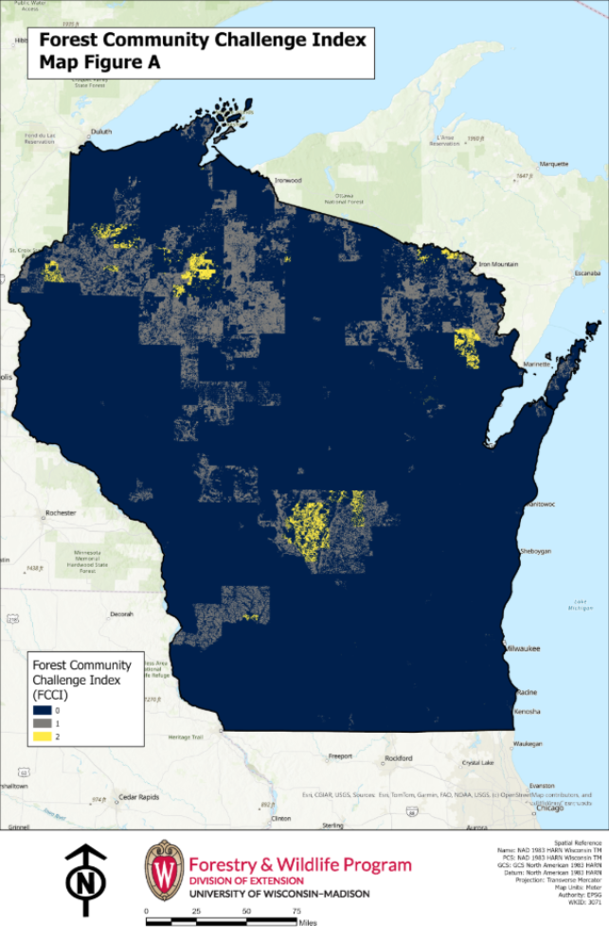
Figure 7. GIS analysis of forested cover and community resilience challenges indices (FCCI) for targeted advertisement. Yellow (2) represents areas of high forested cover and high poverty areas, whereas blue (0) represents low forested cover and/or low poverty areas. Public and Tribal land were forced to a “0” value to exclude them from the analysis.
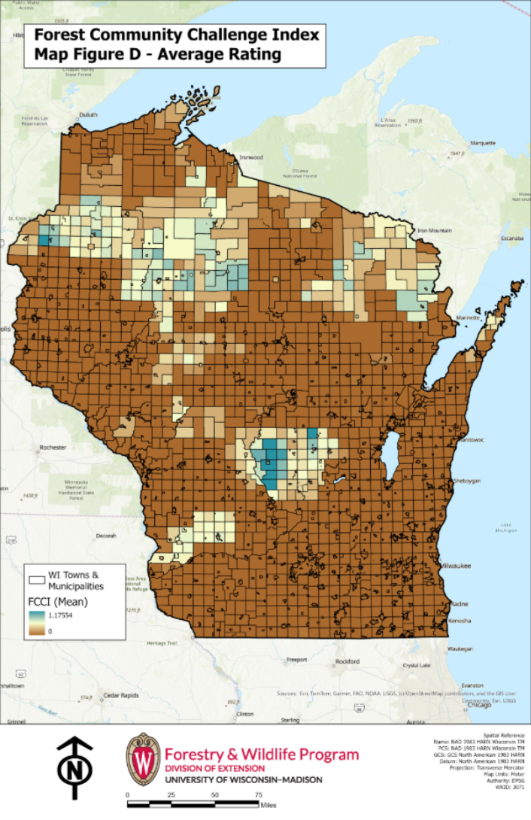
Figure 8. GIS analysis showing the mean FCCI score in each WI township, village, and city. Townships with higher average FFCI scores (teal) could be selected for targeted advertisements of the Forest Resilience Series. Public and Tribal land were forced to a “0” value to exclude them from the analysis.
Table 1. The FFCI analysis identified 10 counties in WI that had the highest mean scores of townships and municipalities with 1.) high forested cover and 2.) high CCRI scores. These 10 counties will serve as key high poverty areas to focus future programming in, track enrollment in webinars/workshops, and develop collaborations with strategic partners for further educational content on forest resilience and forest carbon education.

County Name | FCCI Ranking | Sum of mean FFCI scores for townships and municipalities
Rusk | 1 | 16.18
Adams | 2 | 14.74
Washburn | 3 | 12.86
Price | 4 | 11.98
Burnett | 5 | 11.57
Waushara | 6 | 9.98
Sawyer | 7 | 9.21
Richland | 8 | 7.07
Marquette | 9 | 6.72
Forest | 10 | 5.91

WDNR Wildland Urban Interface (WUI) subdivisions
The WDNR has both identified the need to increased prescribed fire and reduce community risk to wildfires. In the 2020 Statewide Forest Action Plan (Pg. 38), WUI areas within the Northwest Sands and Northern Highland Ecoregions are present.

WDNR wildfire and prescribed burn dashboards
The WDNR tracks both historic and current wildfires and prescribed burns for WI.

WI prescribed fire needs assessments
Two WI prescribed fire assessments have been conducted that demonstrate the need for prescribed fire capacity building in these 2 ecoregions: a WPFC 2021 analysis and a 2015 peer reviewed statewide fire analysis.

National Woodland Owner Survey (NWOS)
The NWOS has survey data from 2018 and 2023 for WI that identifies concerns of wildfire risk, how many landowners have conducted/intend to conduct a prescribed burn, motivations for owning woods, among other data.

Proposal Outcomes

Short term (learning and awareness)
- Landscape-scale analyses are developed that guide where forest restoration and fuel load reduction projects should be prioritized in northern WI.
- WI forest praticioners understand the importance of expanding prescribed fire use in fire-dependent northern forest ecosystems.
- WI landowners understand the importance of expanding prescribed fire use in fire-dependent northern forest ecosystems.
- WI forest practitioners and WI landowners understand the cultural significance of fire for the federally recognized tribes of WI and are aware of Traditional Ecological Knowledge (TEK) concepts.

Medium term (action and behavior change)
- WI landowners actively conduct more prescribed fire and forest restoration projects.
- WI landowners indicate their confidence in performing prescribed fire and forest restoration projects is increased.
- WI landowner participation in federal and state cost-share programs for forest management projects is increased.
- The number of forest management plans incorporating prescribed fire in northern WI is increased.

Long term (broad social or environmental condition change)
- WI fire-dependent forests have decreased their climate change vulnerability.
- Wildfire risk in northern WI is drastically reduced due to holistic fire-dependent forest management.
- The WI public supports the role of fire in sustaining their recreational, cultural, economic, and spiritual connections to the northwoods.

Target Strategies

Task 1. Geospatial Landscape-scale analyses
- LANDFIRE inventory analysis for the 2 ecoregions (NW Sands and Northern Highlands).
- Garrett creates a predictive modeling analysis overlayed with WI parcels to ID landowners to communicate with about forest restoration.
  - Intent = can we identify areas of the landscape where we need to prioritize fire-dependent restoration based on landscape connectivity, rare ecological communities, operational feasibility (i.e. close to roads), and maximum wildfire risk reduction based on modeling runs?
- Incorporating Fieldmaps or Survey123 to get public participation in modeling efforts?
- Incorporate TEK into model development or develop a process for Tribal input throughout the modeling process (not just at the back end).

Task 2. Convening fire working groups with key stakeholders

Task 3. Developing a theory of change and strategic goals

Task 4. Forestry and Natural Resource Professional (NRP) outreach

Task 5. Landowner outreach and workshop development
- Utilize landscape geospatial analyses for outreach and workshops to identify “high priority outreach regions”.
  - Central goal is to increase awareness and acceptance of prescribed fire
  - Link Underserved Landowners to existing resources and developed programs

